Design Document: Sudoku Solver

By: Sarah Kazi, Zaynab Almoujahed, Kayla Condrella

**Purpose:** The purpose of the project developed is to create an empty Sudoku grid that can then be loaded with a sample puzzle and played. The Sudoku Solver implements helper buttons that let the user know what values are valid and can also provide hints if needed. The purpose of the project is to essentially design a solver for Sudoku, and to allow the user to use the hints to have it solve the puzzle for them. The project can also save a current puzzle’s state to a file, which can then later be loaded at another time. The project will be for users who want to play Sudoku.

The project uses algorithms to resolve cells one at a time until the entire board is solved and also presents a panel on the side to let the user know whether they are currently using the eraser, a helper button, or what their candidates for a specific button is.

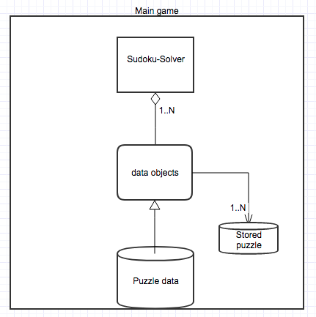 **High Level Entities:**

There are four major high level entities in the project. The overall main game contains the Sudoku solver object, which holds all the contents needed to play the game.

Data objects include all the data we have to play the game, which includes arraylist of buttons, the panels of information we display.

We have the puzzle data which goes into the data objects and loads it onto the Sudoku solver GUI.

We also have information going into a stored puzzle data file, which takes the information on the GUI and stores it in a file.